POINT MOVING AVERAGES
Pearson Edexcel - Monday 14 November 2011 - Paper 4 (Calculator) Higher Tier
1.
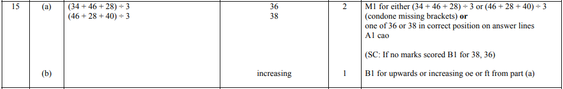
Pearson Edexcel - Tuesday 10 November 2009 - Paper 4 (Calculator) Higher Tier
2.
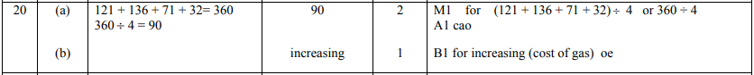
3.

